**LAB REPORT #5** Name: Owais Rao

**Experiment No.5(extra)** Roll No.:22L-7638

Class: BSEE-1A2

**Introduction:-**

An if statement consists of a boolean expression followed by one or more statements. It can be followed by an optional else statement, which executes when the boolean expression is false. We can use one if or else if statement inside another if or else if statement(s).

**Objective:-**

* To be able to evaluate relational expressions.

**Procedure:-**

With the help of lab manual, I was able to write codes for given exercises. They are as follows with their outputs:-

**Exercise 1:-**

**a) Output:** Good Bye

**b) Output:** x is greater than 4

x is 6

x is checked

**c) Output:** x is greater than all values

**Exercise 2:-**

#include <iostream>

using namespace std;

void main()

{

int costOfNotebook, money, notebooksNeeded, totalNotebooks, remainingNotebooks, remainingMoney, nextSemNotebooks;

int numFreeNotebook, theoreticalNotebooksBought;

cout << "\nEnter Money: Rs.";

cin >> money;

cout << "\nCost of one notebook: ";

cin >> costOfNotebook;

cout << "\nNumber of notebooks needed: ";

cin >> notebooksNeeded;

theoreticalNotebooksBought = money / costOfNotebook;

if (theoreticalNotebooksBought > 7)

{

numFreeNotebook = theoreticalNotebooksBought / 3;

totalNotebooks = theoreticalNotebooksBought + numFreeNotebook;

nextSemNotebooks = totalNotebooks - notebooksNeeded;

if (nextSemNotebooks < 0)

{

nextSemNotebooks = 0;

}

cout << "\nNumber of Notebooks bought: " << totalNotebooks << endl;

cout << "\nNumber of Free Notebooks: " << numFreeNotebook << endl;

if (totalNotebooks <= notebooksNeeded)

{

remainingNotebooks = notebooksNeeded - totalNotebooks;

remainingMoney = remainingNotebooks * costOfNotebook;

cout << "\nMoney Required to buy the remaining books: " << remainingMoney << endl;

cout << "\nNotebooks for next Semester: " << nextSemNotebooks << endl;

}

else

{

cout << "\nNotebooks for next Semester: " << nextSemNotebooks << endl << endl;

}

}

}

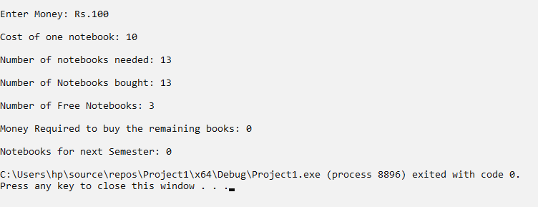

|  |  |
| --- | --- |
| **Input** | **Output** |

|  |  |  |  |  |  |
| --- | --- | --- | --- | --- | --- |
| **Money Available** | **Cost of one notebook** | **Number of notebooks needed in the semester** | **Number of notebooks you can buy** | **Additional money needed if books are not enough** | **Number of extra books otherwise** |
| 100 | 10 | 13 | 13 | 0 | 0 |
| 100 | 10 | 14 | 13 | 10 | 0 |
| 100 | 10 | 7 | 13 | 0 | 6 |
| 100 | 12 | 12 | 10 | 24 | 0 |
| 160 | 12 | 10 | 17 | 0 | 7 |

**Issues:-**

No issues were faced.

**Conclusion:-**

* I was able to evaluate relational expressions.

**Applications:-**

* The if-else-else-if control structure is typically used to check multiple conditions.
* We use the if-else statement to run a block of code among more than one alternatives.